Wise Words - Pro Tour-New York
Gary Wise
Tuesday is a word that has a whole new meaning to me, because Tuesday is the day 'it' happened. Since I started writing Wise Words, Tuesday has been the deadline for each instalment of this column, so as I reached the one-week anniversary of September 11th, I was suddenly struck with the realization that it was time for life to go on. That's why the first two paragraphs of this week's column will be the only ones to mention that incident.
While obviously the destruction of the World Trade Center overshadows all, two days earlier, the Pro Tour's finest were competing in an event, Pro Tour-New York, which has, is and will be important in our little pocket of the global community. With many players not getting many chances to visit one of the greatest cities in the world, some stayed behind to tour a little. Fortunately, all reports suggest that the Magic community escaped virtually unscathed, with none of the visiting luminaries or Neutral Ground regulars being injured in the attack.
The Tour itself provided us with or continued a number of stories of importance, from Kai Budde's continuing streak to Your Move Games's early exit from the PT to Car Acrobatic Team's setting a new standard for excellence in the Team Rochester format. Here's a look at those stories and a few more.

The Amazing Kai
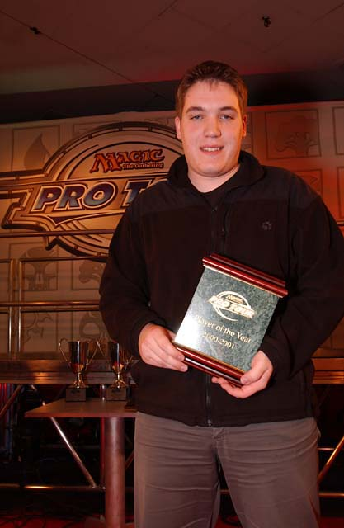
How insane is this streak Kai is on? Just yesterday I was writing about how amazing three Pro Tour wins and a 9-0 record on Sunday was and now he's gone and made that chump change. Four Top 8 finishes, four wins. Unbelievable.
As with Jon Finkel before him, Kai's dominance, while extraordinary, is doing a lot more than netting one player a lot of money (though it's definitely doing that). Kai, Zvi Mowshowitz, Kamiel Cornelisson and other multiple Top 8 types from the past year are taking Magic to the next level as a competitive sport, with the repetitive success stories proving the legitimacy of the game's claim to be based on skill rather than luck. When players repeatedly show themselves to be better than others, they in turn prove the results reflect who most deserves to win when the game is played on an equal playing field.
When the Masters for New Orleans was announced, Cornelisson sat in second place with a very respectable 79 pro points for the last calendar year. That's only 35 points behind Kai's 114. In other words, if the German Juggernaut had not bothered to show up to Pro Tour-Barcelona, thus forfeiting his victory there, he'd have been reduced to a mere 82 pro points in the last year, placing him in... well... first.
Kai, whose recent win at Grand Prix-London could be considered a slow weekend, may have disappointed a lot of the participants in the Sideboard's Fantasy Pro Tour. With three wins In the last calendar year, and the Fantasy Pro Tour allowing for the selection of 8 players with a combined 100 PT points, Kai has now broken the system, with his points alone meaning that anyone picking him would have too many points for a legal team.
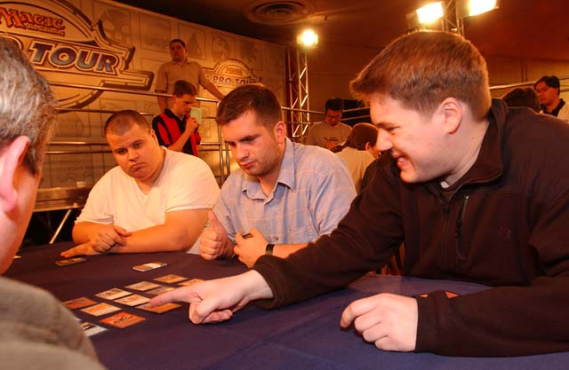
The German Juggernaut's performance with Phoenix Foundation (Marco Blume, Dirk Baberowski) has fueled a couple of debates: Whether his Sunday win streak is still intact and the ongoing greatest player of all time argument. In the semifinals against Car Acrobatic Team, Kai's shaky mana base wrecked him when he lost his individual match up against friendly rival Andrew Johnson, but his teammates were able to take out Aaron Forsythe and Andrew Cuneo to secure the team's victory.
So is the streak alive? "Absolutely" says WotC employee and Pro Tour historian Randy Buehler "Andrew Johnson is definitely deserving of a footnote, but the streak goes on." The logic goes that while Kai did lose to Andy J, the Team Rochester format goes far beyond individual wins and losses. With factors like the potential for drafting one's self their team's weakest deck involved, the decision has been made that in the end, if the team gets the DCI points it's a win, if they don't it's a loss. The streak continues.
So, with the eleven match Sunday streak, twice as many Pro Tour wins as anyone else, three wins in a year in three different formats, a World Championship and Player of the Year title to his credit has Kai done the unthinkable in passing Jon Finkel as the greatest ever? Tough call. I don't think there's any doubt that right now Kai is the best to have ever played the game, showing strength in all formats and dedication to his craft, but it's hard to argue against nine Top 8 finishes. That Jon has done what he's done over an extended period of time in consistent fashion definitely deserves credit: after all, as good as Kai is, you have to have some luck to go 11-0 against the masters of a given format. Throw in Kai's lack of success in the Masters and you have a very close race. In other words, it's like asking which was better in Limited, Morphling or Masticore. The answer: who cares? They both win.
As for the rest of the Pro Tour, there's still some hope, after all, it isn't like Kai won Worlds, Tokyo or LA. Regardless, as he's won everything else under the sun, it's nice to know that his incredible success hasn't changed him: he's still the same old blunt, omni-confident Magic fanatic he's always been. He's supposed to be going back to school this year, but if he can keep playing as much as he has been, there's no reason to believe the streak won't continue.

Baberowski
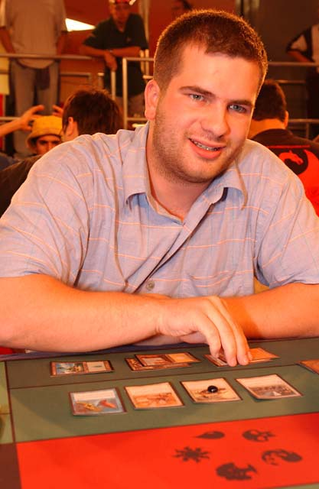
Two-time Pro Tour champ, Dirk Baberowski
Overshadowed by Kai's win was the fact that long-time running mate, playtesting partner and friend Dirk Baberowski was busy lifting himself into Magic's elite circles, winning his second Pro Tour. For the record, Dirk is only the fourth player to do so, joining, Kai, Finkel and Tommi Hovi in their little club.
What makes all this all the more impressive is Dirk's absence from the Pro Tour for almost a year. Baberowski's last appearance at the PT was in Chicago, where a disappointing finish cemented his decision to retire from Pro Tour ranks. Done school without a job that he was happy with, Dirk decided it was time for real life, trading in playing cards for plane tickets, starting his own travel agency.
Staying in touch with the Magic world from his computer thanks to IRC, Baberowski was never too far removed from the game, but the desire to return to the pro ranks never seized him. LA, Tokyo, and Barcelona came and went without Dirk attending, making good on his word to stay away. Then he got the invitation that he couldn't refuse.
With his good friend Kai dominating the PT world, Dirk and buddy Marco Blume decided to check with Kai and see whether he was teaming up with anyone for New York, and Kai came back with the suggestion the three of them work together. The team was set, made official only at sign up the night before the event, and the rest is history.
Now, Baberowski, who also made Top 8 at PT Chicago '99, has some tough choices ahead. Putting an estimated 14 hours a day into his business, he knows he can't dedicate the kind of time needed to be a pro player thanks to his investments, but with 24 PT points etched in stone for this year already, the Masters isn't far away. He says he won't be at New Orleans and that Kai will have to drag him to Osaka (where the Team Masters will be held), but only time will tell us if he can turn his back on the possibility of making thousands for something he'd do anyways.

Your Move Games
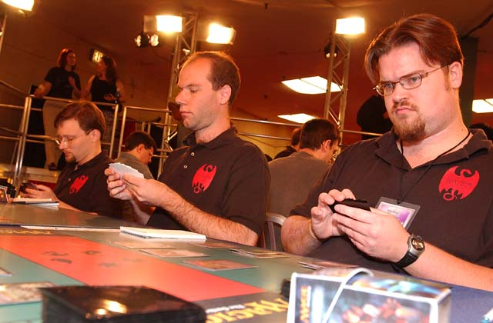
The first big story of the tournament came at the end of third round, when the team of all teams, Your Move Games, decided to drop out of the tournament. The news that Darwin Kastle, Rob Dougherty and Dave Humphreys, fresh off their win at GP-Columbus, had given up at 1-1-1 while still in contention for Day 2 swept through the room. Here's a look at the factors that brought them to the decision to drop.
That Rob, Darwin and Dave should be a team was obvious going into GP-Columbus. They'd had unparalleled success, knew each other's styles and strengths and had no weak link, with all three players being among the world's best. Then they won the GP.
The result of their victory in Columbus was that their rating was so high that, as Dougherty explained to me 'if we were to never play a non-Masters match again, we'd be qualified for the next two, maybe three Team Masters on rating alone.' Unfortunately, with the Columbus rating not being put into the system for an extended period of time, by the time they figured this out, most of their Pro Tour and YMG colleagues had affiliated themselves in groups of three for New York.
"We would have asked (team member) Justin Gary's team if they were interested in doing a swap of some sort, but he's already made a trip to New York for practice purposes and there would have been problems with Zvi and Alex having to accept that they couldn't earn a Masters spot, so we didn't feel it was worth asking." As Darwin, Rob and Dave would play together in the Masters, any team any of them was a part of wouldn't be able to do so as well. For players like Mowshowitz and Shvartsman, one has to think this wouldn't have been an acceptable situation.
The other option was to swap one of the team members to YMG2 in exchange for one of their own, the most likely scenario seeing Kastle's roommate Danny Mandel join Darwin and store-owner Daugherty while Humphreys would join Chad Ellis and Peter Vabulous. Said Rob, 'They were basically doing us a big favor by making that option available to us, but we didn't want to deprive them of Masters possibilities and the team synergy wasn't there. It just wasn't as comfortable as what we're used to."
The option was suggested one last time on the way to New York, but the trio had figured out that not only could they afford two losses or draws and still be assured a place in the Osaka masters, but also that once they tried implementing the switch, WotC would figure out that they'd broken the selection process for the Masters, meaning they would probably come up with new criteria in a year. It was decided that the two YMGs would each remain intact and that the parent team would take their chances with team Sealed, knowing that if they could survive to Day 2, their Team Rochester track record would probably stay true. Unfortunately they never got that far, and after they lost to Godzilla (Ben Ronaldson, John Ormerod and Ollie Schneider) and drew with Team Denmark (Dennis Berthelsen, Allan Christensen and Lasse Wehner), the decision to drop was easy, with the expected dividends of the Masters far exceeding those of a Pro Tour that they'd started 1-1-1.

Car Acrobatic Team
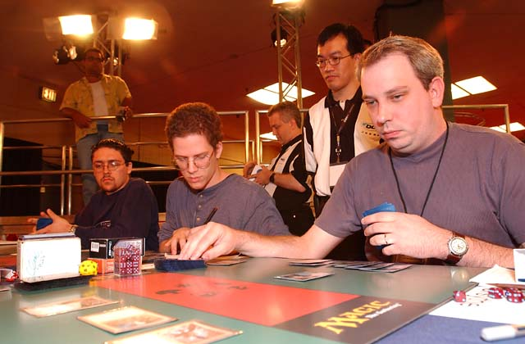
Many players have called Team Rochester the most skill-intensive format in Magic. The potential to outdraft or outplay opponents balanced by the elimination of luck-based losses thanks to the best two out of three format suggests that if nothing else, there is less luck involved in the format than any other in Magic. In three Pro Tours though, with all this talk of skill, only three players have been consistent enough to make Sunday more than once: Andrew Johnson, Aaron Forsythe and Andrew Cuneo.
Car Acrobatic Team developed a reputation a year ago as successful disciples of Mike Turian, but this year took it a step further, making their second consecutive Top 4 while Potato Nation failed to make Day 2. With their second place finish a year ago, they were obviously one of the better teams going into New York, but with a fourth place finish this time around, they have to be considered one of the best teams in the world.
The key to this union, aside from constantly playing together along with Turian, Eugene Harvey and the rest of Team CMU, may be the way their personalities compliment one another. Cuneo's quiet reflection and Johnson's opinionated confidence weigh one another out, while Forsythe sits right on the middle. Their time together has made their communication impeccable and has led to each member's understanding one another's strengths and weaknesses. In short, they aren't three individuals, but the essence of a team.
CAT has been patient for the last year as Turian received a lot of the credit for their success, but now all that changes. It's the fact that they won't let success go to their head, continuing to play for love of the game, which should keep this successful combination intact for years.
That's about it for this week. With New Orleans six weeks away, there's a bit of a break in PT action, so next week may see some strategy-based discussion. Until then, hope all is well. Have a good one.

